**ECSE 403 - Control**

**Laboratory 5 - Report**



Mohamed Reda EL KHILI - 260678513

François-Eliott Rousseau - 260670000

Ismail Faruk - 260663521

1. Considering the position as the output and the coefficients from the previous laboratory, we obtain the transfer function: .  
   We obtain the bode plot shown below with a gain margin of infinity and a phase margin of 19.8 deg.  
     
     
   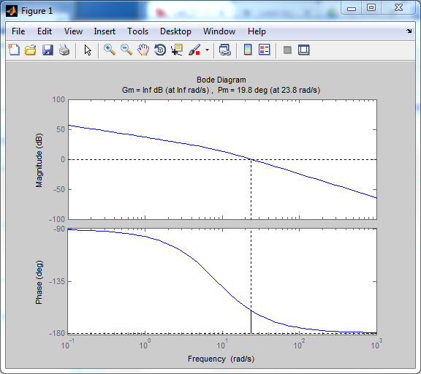

Figure: Bode Diagram of the system

1. We use Kp = 0.45 and we obtain a phase margin of 20.9 deg and a gain margin of infinity.  
   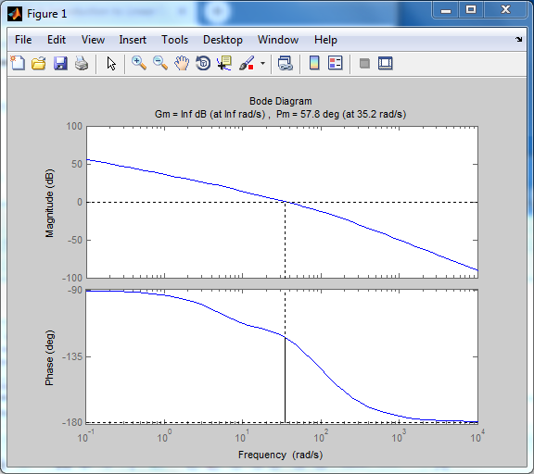

Figure: Open Loope Bode Diagram

* 1. Done
  2. Done
  3. The current phase margin of the open-loop system is 20.9 deg
  4. Taking a safety margin of 5 degrees, the required phase is 44.1 deg.
  5. We have a required phase of 44.1 degrees. Solving the equation:  
     . We get
  6. By looking at the Bode plot we find a desired frequency wm of 35.2 rad/sec
  7. We get, = 0.012.  
     Hence, our lead controller is   
     With this lead compensator, we reach a phase margin of 57.8 deg.

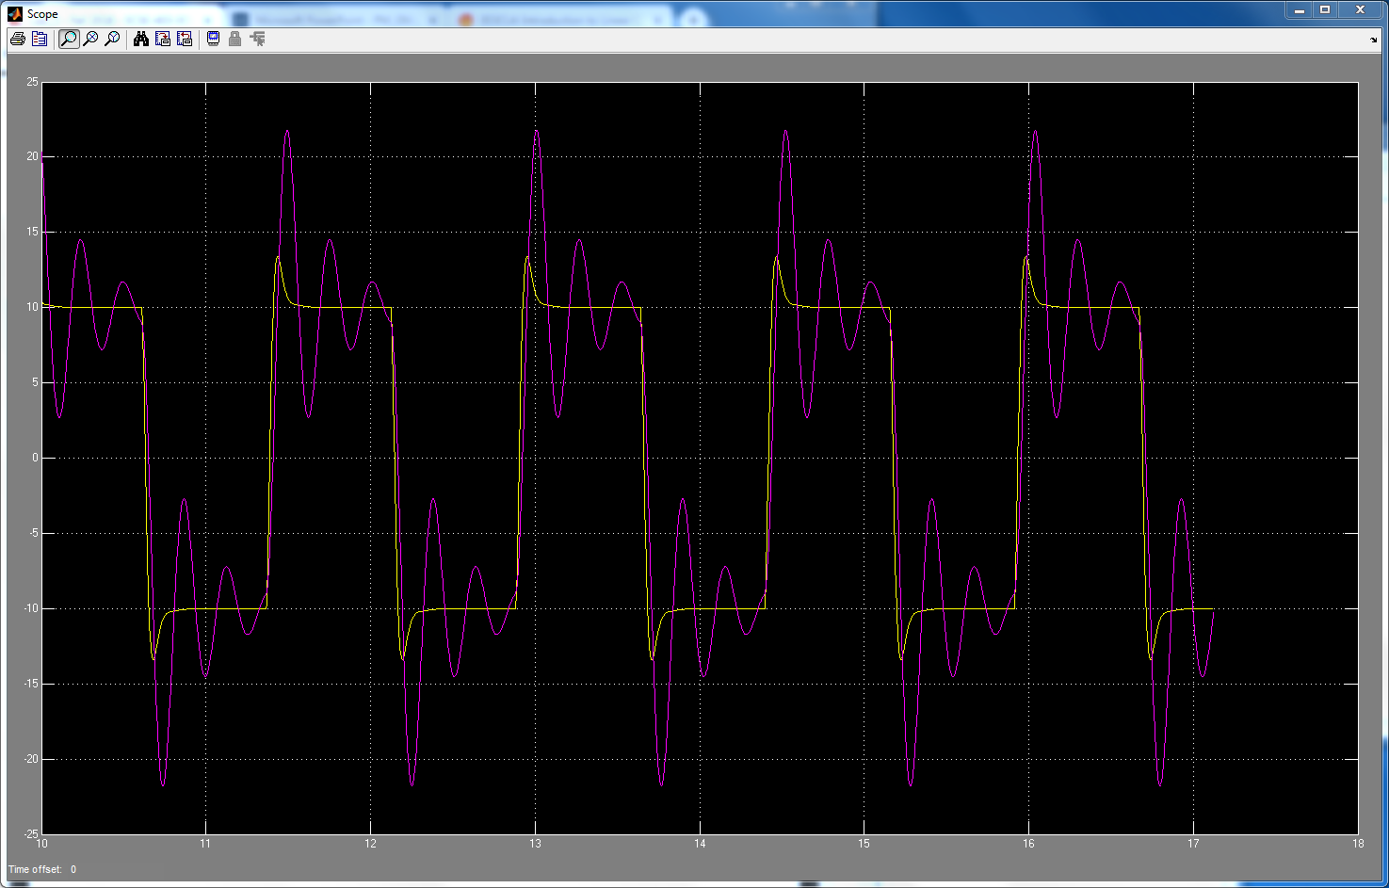

Figure: Step response of proportional feedback controller, with and without the compensator - Model

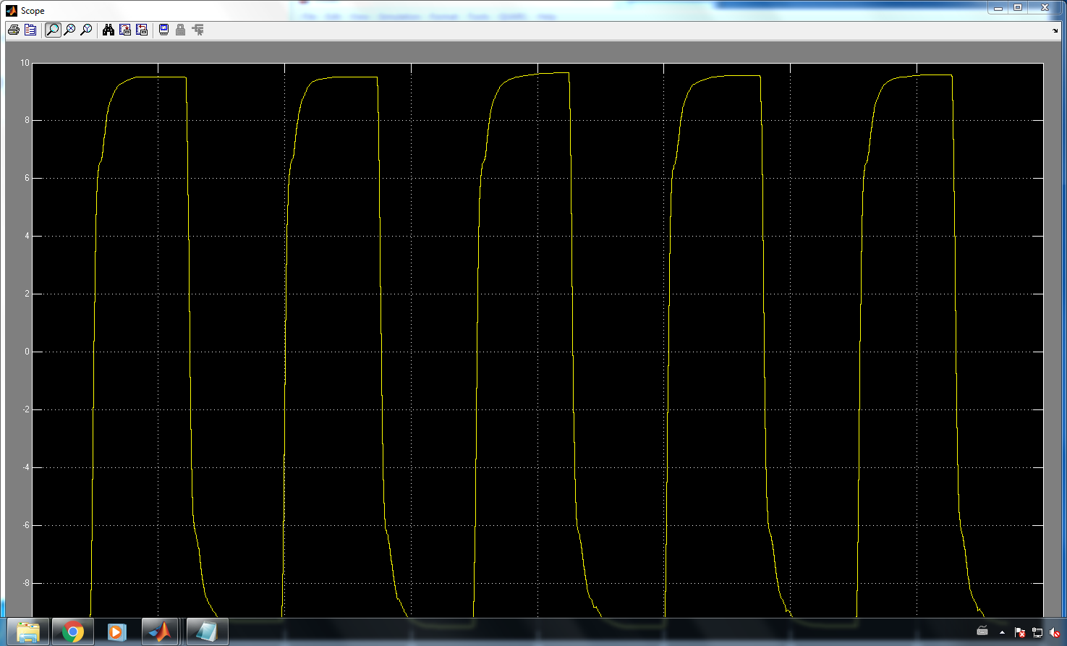

Figure: Step response of the system to proportional feedback controller with Lead compensator - Physical

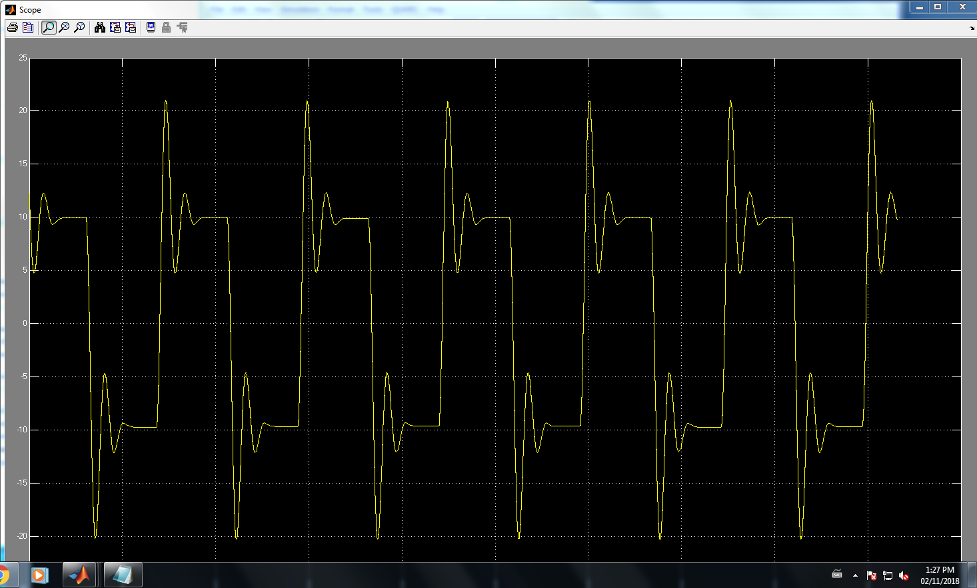

Figure: Step response of the system to proportional feedback controller without Lead compensator - Physical

1. We can see that adding the lead compensator allows the system to get rid of the overshoot and to have a slower rise time by having a bigger Kp. We also have a bigger phase margin which makes the system more stable. We have a steady state error of 2.3%.  
   The bandwidth of the closed loop system is at 51 rad/s (frequency at which the magnitude goes to -3dB).
2. 1. Done
   2. Taking the limit of as s goes to 0, we find:
   3. We had a steady state error of 2.3% using the lead compensator. Hence, we now want a steady state error of 0.23% with the lead-lag compensator as asked. We thus get:   
      We thus obtain
   4. By looking at the bode plot, we find that at w = 6.92 rad/sec, we have the required phase margin of -110 deg.
   5. We find using w = 6.92 rad/sec a dB-drop 17.8 dB and we get
   6. We finally get T = 1.4451  
        
      Hence, our lead lag compensator is given by:  
        
      Plotting the Bode Plot, we obtain a phase margin of 57.9.

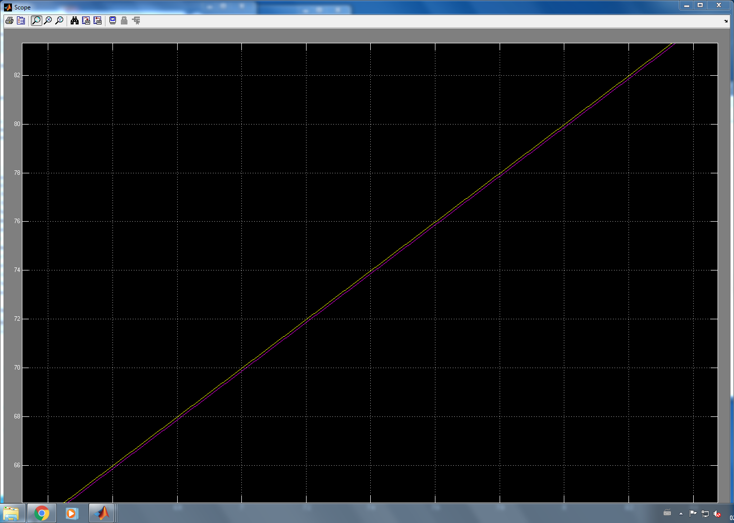

Figure: step response of proportional feedback controller with LEAD and LEAD-LAG compensators

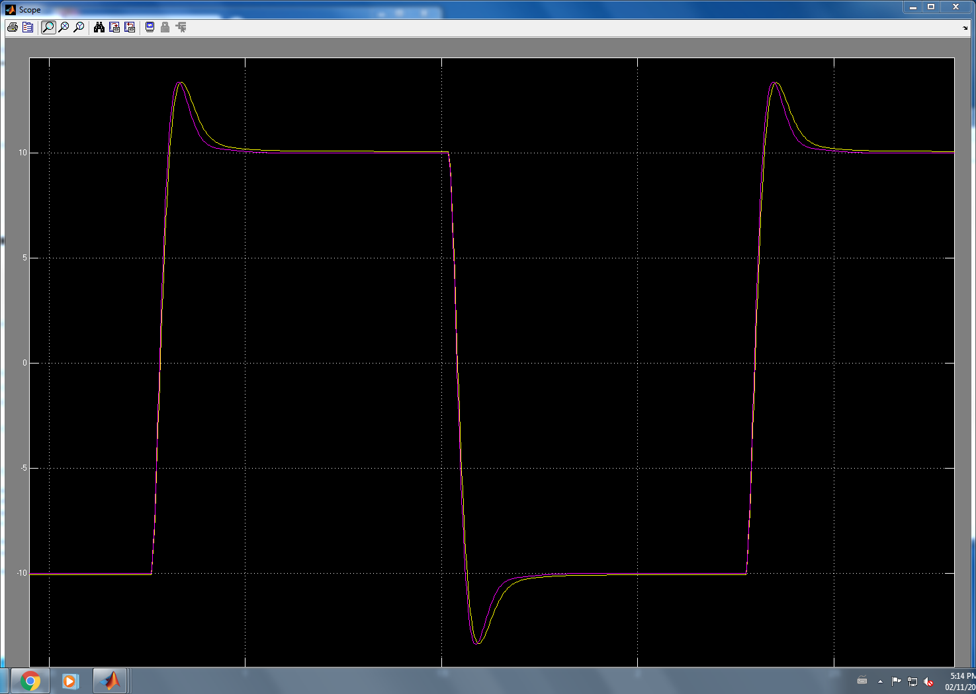

Figure: Ramp Response of proportional feedback controller with LEAD and LEAD-LAG compensators

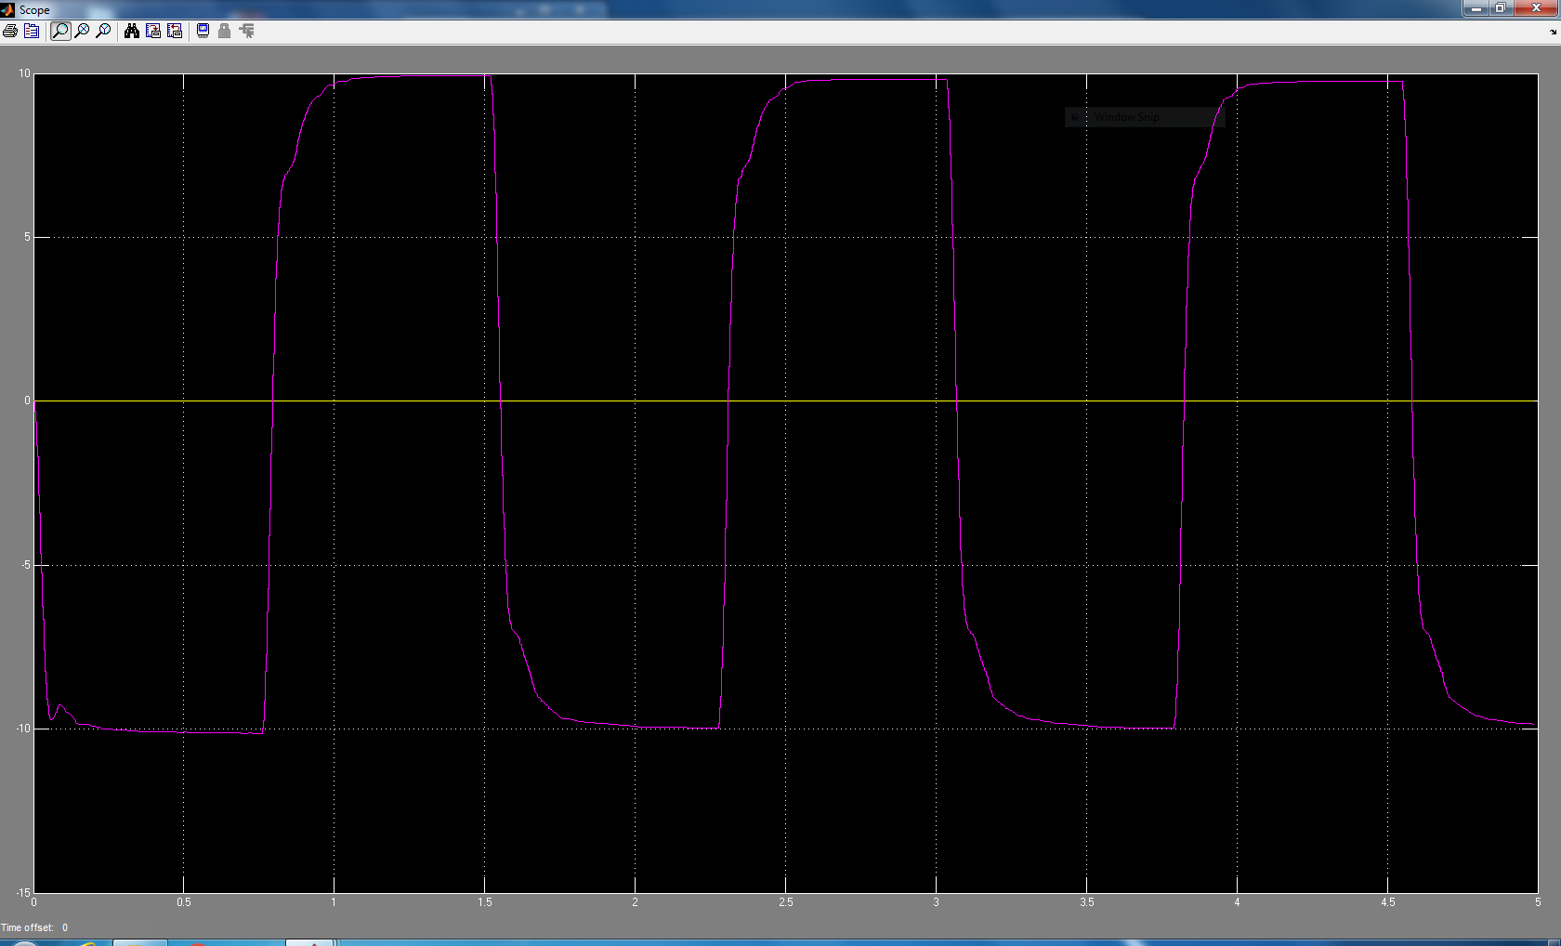

Figure: Step response with Lead-Lag compensators

1. The Lead-Lag has smaller rise but higher settling time than PID. Lead-Lag also has lower steady state error and no overshoot.

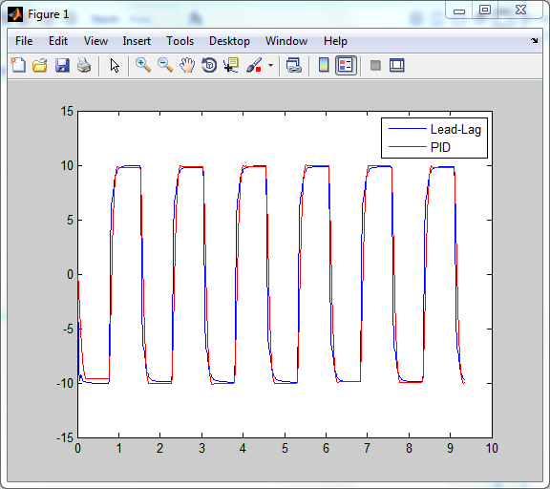

Figure: Lead-Lag compensators vs PID

Appendix

%% Q1  
s = tf('s');  
G = 1200/(s*(s+8.569));  
  
  
%% Q2  
H = 1200*0.45/(s*(s+8.569));  
bode(H)  
margin(H)  
  
%% Q5  
C = (0.067*s+1)/(0.012*s+1);  
  
Z=C*H;  
margin(Z);  
bode(Z);  
  
%% Q6  
X = 6.899*(1.4451*s+1)/(1.4451*7.7625*s+1);  
margin(Z*X)  
bode(Z*X);  
  
%% Q9  
% time = (simout.time);  
% H1 = (simout.signals.values);   
% H2 = (simout.signals.values); %kp = 0.178, ki = 0.092, kd = 0.0075  
  
% used to find length  
% length(H1); length 4722  
% length(H2); length 4682  
% length(time); length 4682  
% H_t = length(H2); %4682  
%   
% H3 = H1(1:H_t); %extract data of set size H_t  
% H4 = H2(1:H_t); %extract data of set size H_t  
% t = time(1:H_t);  
  
plot(t,H3,t,H2,'r');  
legend('Lead-Lag', 'PID');